**© 2015 – Foxes Team**

<http://process.ws>

**Abstract**

This document describes in detail the Increment Process which will use to define the product.

**Process for Increment**

**Foxes Project**

**Table of Contents**

1. Introduction 2

1.1. Purpose & Scope 2

1.2. Intended Audiences 2

2. Process Objectives 2

3. Process Diagram 2

4. Process Roles & Responsibilities 3

5. Process Description 4

5.1. Launching 4

5.2. Working 4

5.3. Validation 5

3. Advantages 6

4. Disadvantages 6

5. Tool 6

Revision 7

# Introduction

## Purpose & Scope

The process describes activities detail in Increment Process which will use to define the product.

## Intended Audiences

|  |  |
| --- | --- |
| Audience | Reference Purpose |
| Project Manager | To know schedule of Increment and update to project plan. |
| Mentor | Review and guideline for improvement Increment. |
| Requirement Lead & Engineer | Use this document to manage, update schedule and follow it to work in Requirement phase. |
| Architecture & Design Leader | Use this document to manage and update schedule in architecture phase. |
| Architecture & Design Engineer | Read document to know architecture plan and follow it to work in architecture phase. |
| Programmer | Read document to know coding plan and follow it to work in coding phase. |
| QA & Tester | Read document to know test plan and follow it to work in Testing phase. |

Table 1 - Intended Audiences

# Process Objectives

Process of Increment will:

* Define Increment Process to Foxes Team apply and implement in Capstone Project.
* Base on the process, Team will know activities need to implement in Increment and how to do it.
* Provide for customer the product with feature was completed with the best quality.

# Process Diagram

The following figure will give you a big picture about activities

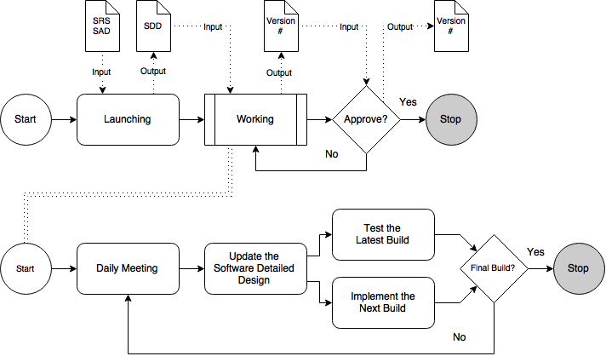

Figure 2 – Increment Process

Document in this sub-process:

* SRS: Software Requirement Specification.
* SAD: Software Architectural Design.
* SDD: Software Detailed Design.

# Process Roles & Responsibilities

|  |  |
| --- | --- |
| Role | Responsibility |
| Project Manager | Gathering all meeting and solve problem between all stakeholder |
| Architecture Engineer | Responsible for architecture design and detail design |
| Requirement Engineer | Responsible for gathering and tracking requirement and support architecture team when need. |
| Programmer | Support team design to make design specification |
| QA Engineer | Ensure architecture and design process are followed as prescribed to ensure project quality are met |
| Customer | Responsible support and approval some document for team development. |

Table 3 - Process Roles & Responsibilities

# Process Description

## Launching

|  |  |
| --- | --- |
| **Required Input** | 1. Software Requirement Specification 2. Software Architectural Design |
| **Expected Output** | 1. Software Detailed Design |
| **Participants** | 1. Project Manager (PM) 2. Requirement Engineer (RE) 3. Architectural Engineer (AE) |
| 1. An Increment lasted 2 weeks and its fixed time (like Sprint in Scrum).   Eg: Increment #01: 08/22/2015 – 09/04/2015   1. Defining detail design for general feature of software and update it frequently. (Sequence Diagram, Class Diagram ...) base on the project plan | |

## Working

### 5.2.1. Daily Meeting

|  |  |
| --- | --- |
| **Required Input** | Software Detailed Design |
| **Expected Output** | Software Detailed Design – Revision # |
| **Participants** | 1. Project Manager (PM) 2. Architectural Engineer |
| Started a work day, have daily meeting to:   1. Show a video to introduce about new feature will be built in that day. 2. Statistic the bug had appeared. 3. Asked 3 question like daily meeting in Scrum:  * What did you do yesterday? * What will you do today? * Are there any impediments in your way? | |

### 5.2.2. Update the Software Detailed Design

|  |  |
| --- | --- |
| **Required Input** | Software Detail Design – Revision # |
| **Expected Output** | The new revision of Software Detailed Design – Revision # |
| **Participants** | 1. Project Manager (PM) 2. Requirement Engineer (RE) 3. Architectural Engineer (AE) |
| 1. SDD and Test Cases will be updated every day. | |

### 5.2.3. Implement the build

|  |  |
| --- | --- |
| **Required Input** | Software Detail Design – Revision # |
| **Expected Output** | 1. Software Detail Design – Revision # 2. Product |
| **Participants** | 1. Technical Engineer (TL) 2. Programmer |
| 1. Nguyên + Hồng: Continue to program next feature. | |

### 5.2.4. Test the build

|  |  |
| --- | --- |
| **Required Input** | 1. Software Detail Design – Revision # 2. Product |
| **Expected Output** | 1. Product – Build # 2. Bug Report |
| **Participants** | 1. Project Manager (PM) 2. QA Engineer (TL) |
| 1. Chi & Tỷ will execute testing with Ad-hoc Testing base on late version Build Product. 2. Hiệp & Toàn will execute testing with Regression Testing. | |

## Validation

|  |  |
| --- | --- |
| **Required Input** | 1. Product – Build # 2. Software Detail Design – Revision # |
| **Expected Output** | 1. Software Detail Design 2. Product - Build # |
| **Participants** | 1. Project Manager (PM) 2. Customer |
| 1. Have the review meeting to consider possible implement next step?. If not, continue to do until the end of time Increment. But the last day of the Increment must be implement Review step to move the next Increment. | |

# Advantages

* After each iteration, regression testing should be conducted. During this testing, faulty elements of the software can be quickly identified because few changes are made within any single iteration.
* It is generally easier to test and debug than other methods of software development because relatively smaller changes are made during each iteration. This allows for more targeted and rigorous testing of each element within the overall product.
* Customer can respond to features and review the product for any needful changes.
* Initial product delivery is faster and costs lower.

# Disadvantages

As additional functionality is added to the product, problems may arise related to system architecture which were not evident in earlier prototypes.

# Tool

* Redmine System.
* Microsoft Word.
* Microsoft Excel.
* Microsoft Visio.

# Revision

|  |  |  |  |
| --- | --- | --- | --- |
| # | Date | Editor | Description |
| 3 | Sep 6th, 2015 | Tỷ Trần | * Updating with new template. * Adding Tables of Figures section. |
| 2 | Aug 21th, 2015 | Chi Tô | * Update Process Description. |
| 1 | Aug 20th, 2015 | Chi Tô | * Create document. |